PRACTICAL NO:6
(GITHUB)

Step-1 To Create and use a repository
Click on the drop down arrow and select New repository as highlighted

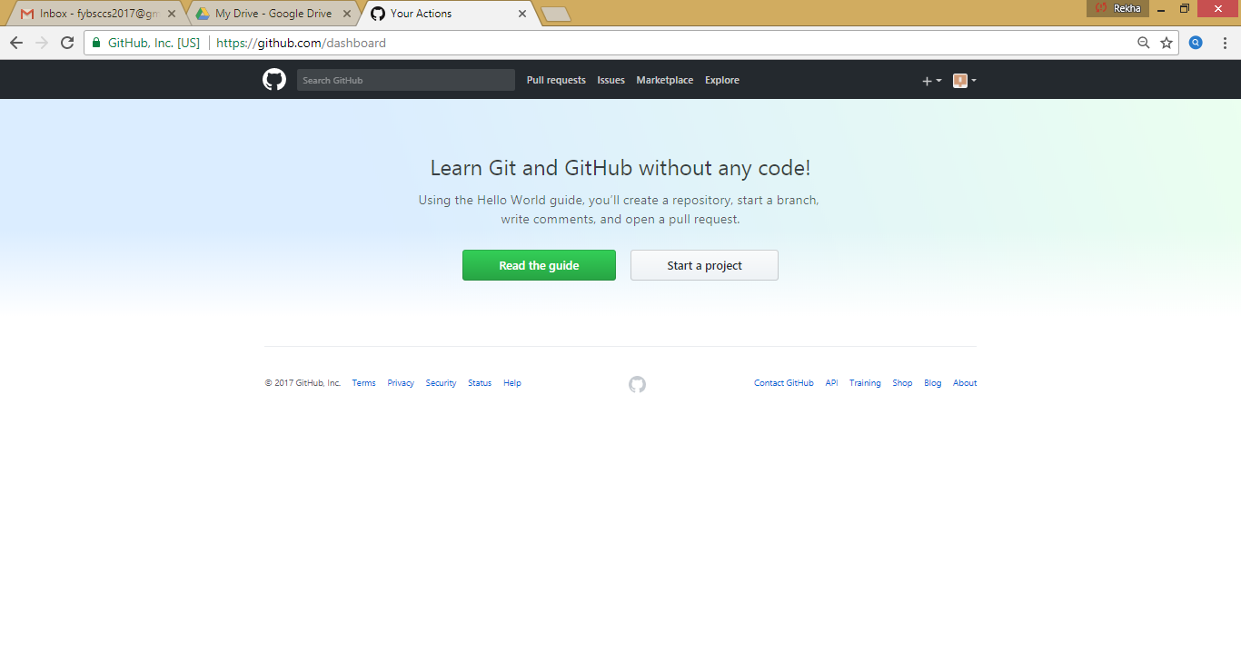

Click on the green button to create a repository

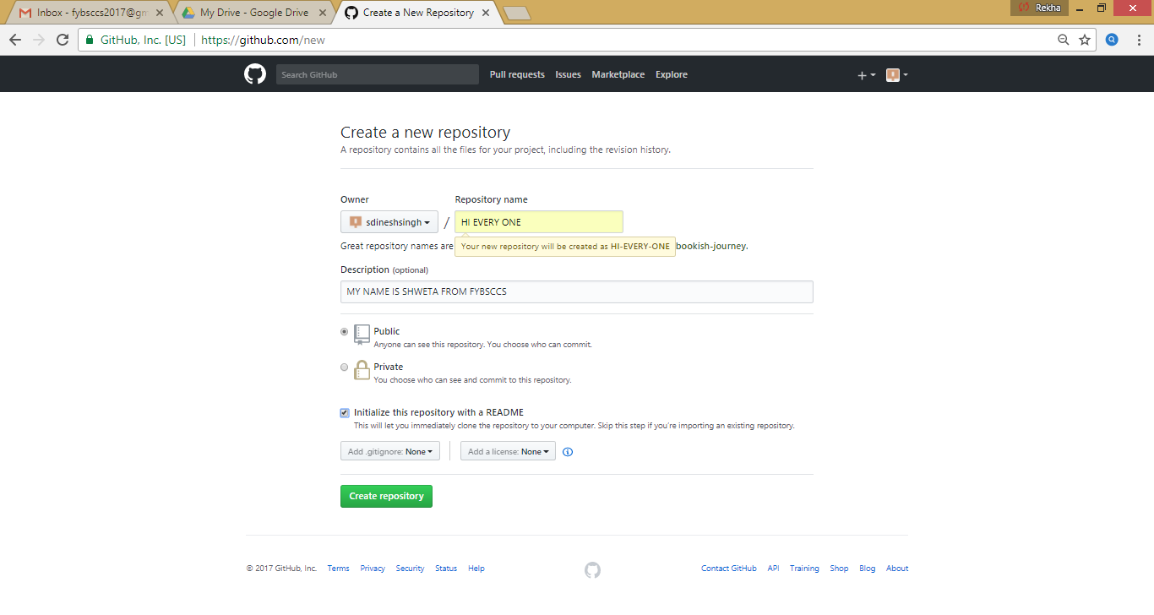

CLICK ON THE CREATE REPOSITORY BUTTON.
AFTER CLICKING ON CREATE REPOSITORY YOU WILL SEE THE FOLLOWING
WINDOW .

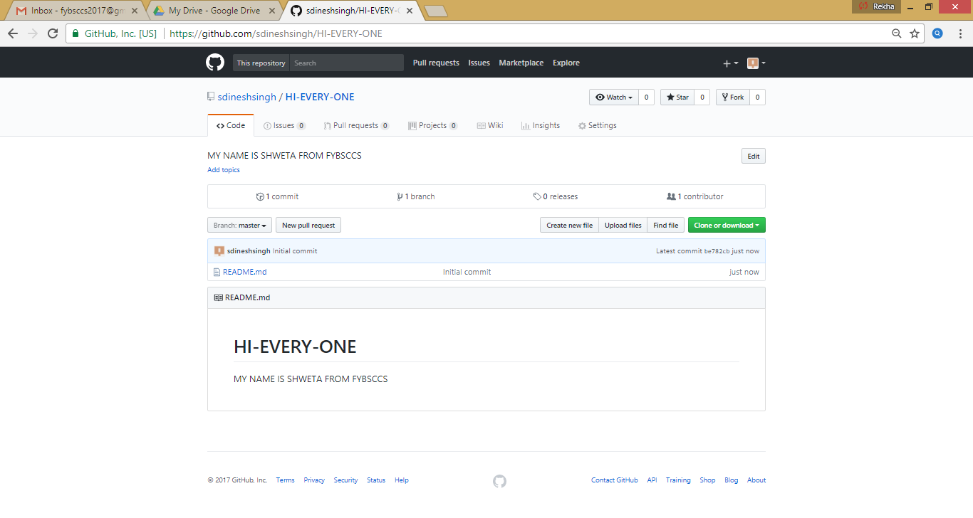

Step-2 To Start and manage a new branch
Click the drop down near the branch master ,type a branch name
readme-edits into the new branch textbox and hit enter

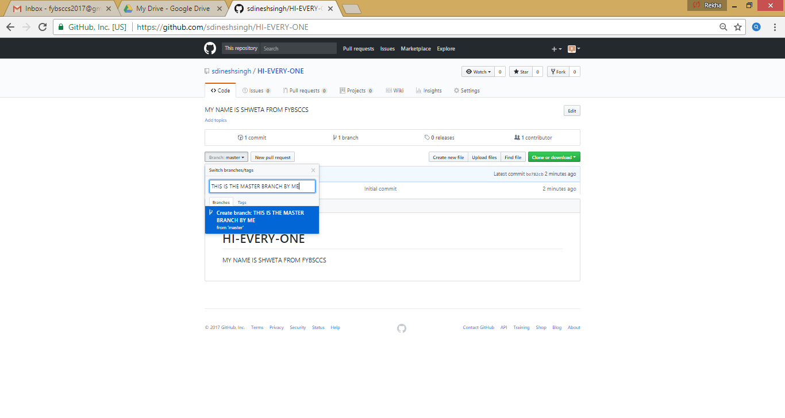

Thus a new branch is created as shown below

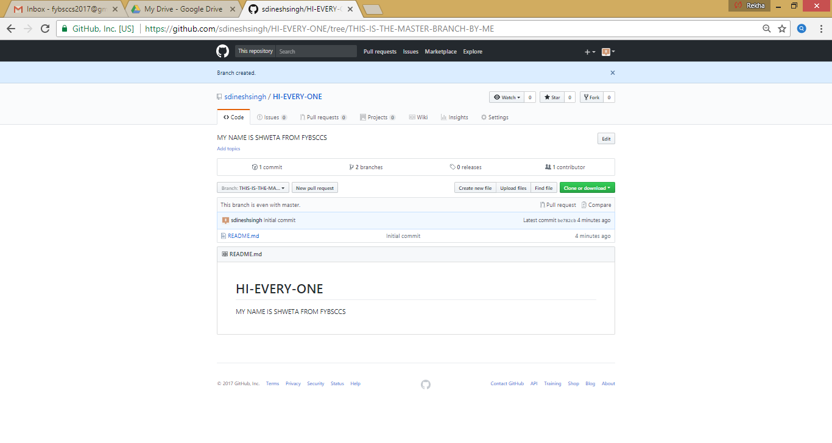
Step-3 Make changes to the file and commit changes
Click the pencil icon in the upper right corner of the file view to edit

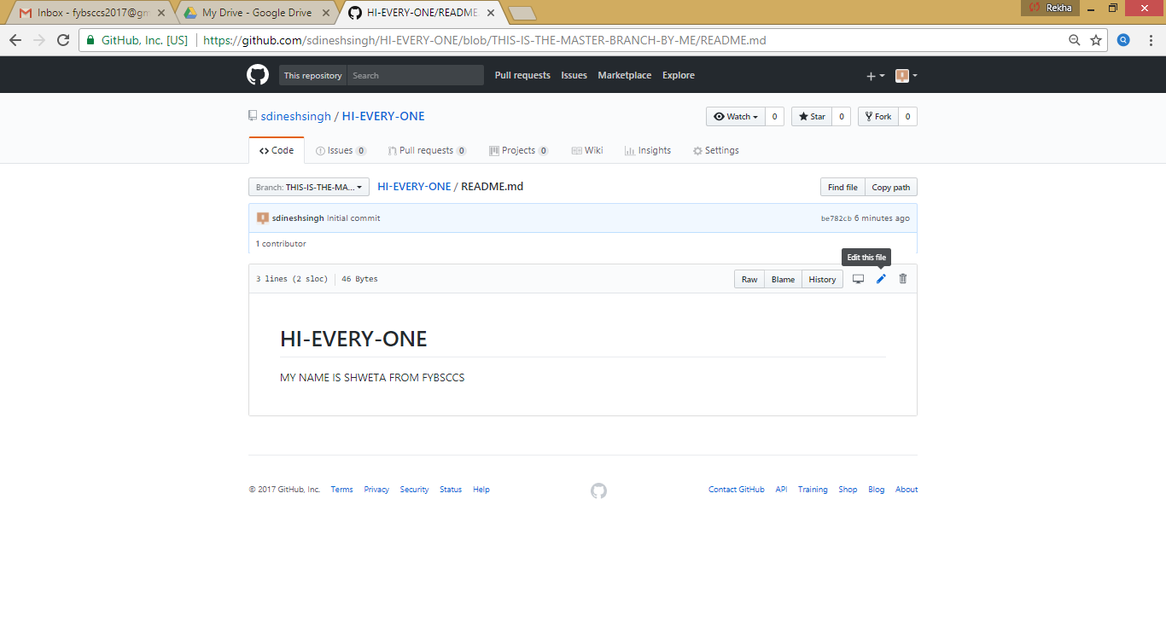

In the editor write a bit about yourself

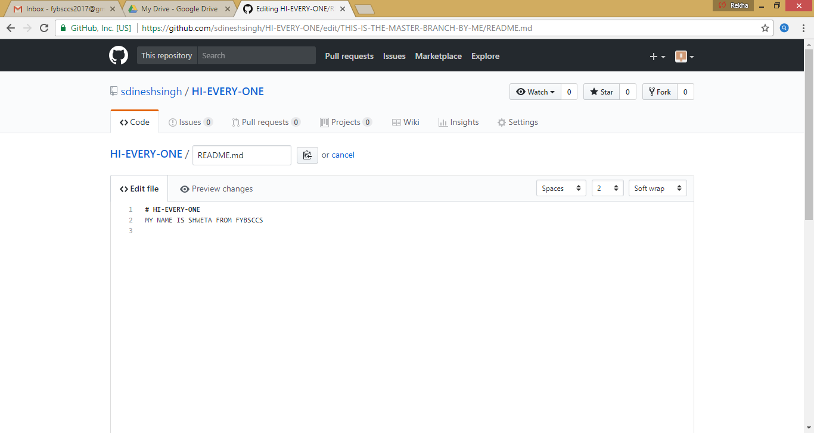

As shown below

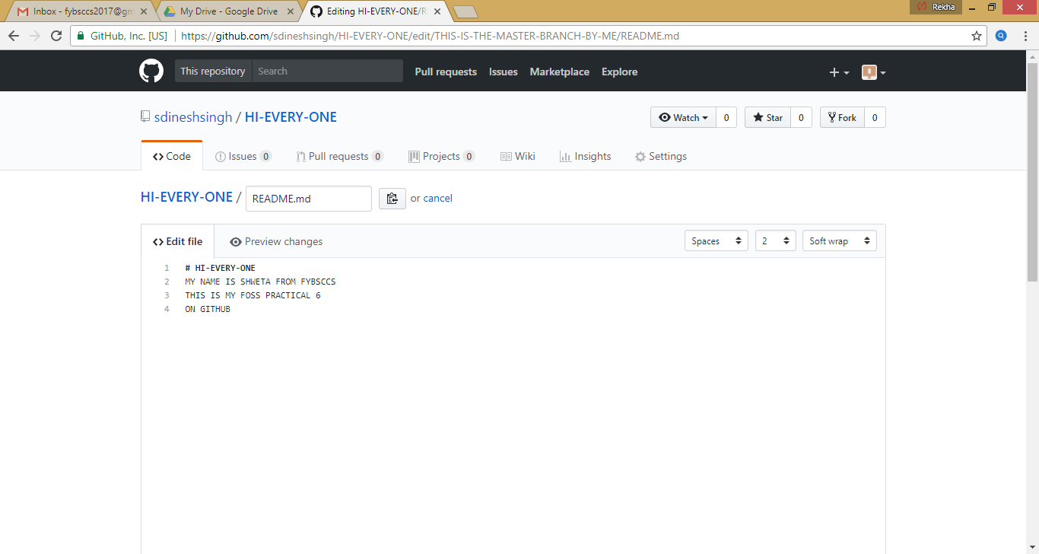

Click on commit changes
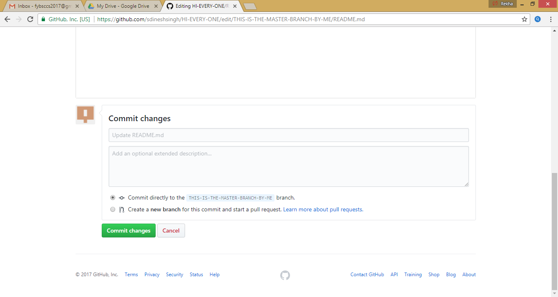

The following window appears

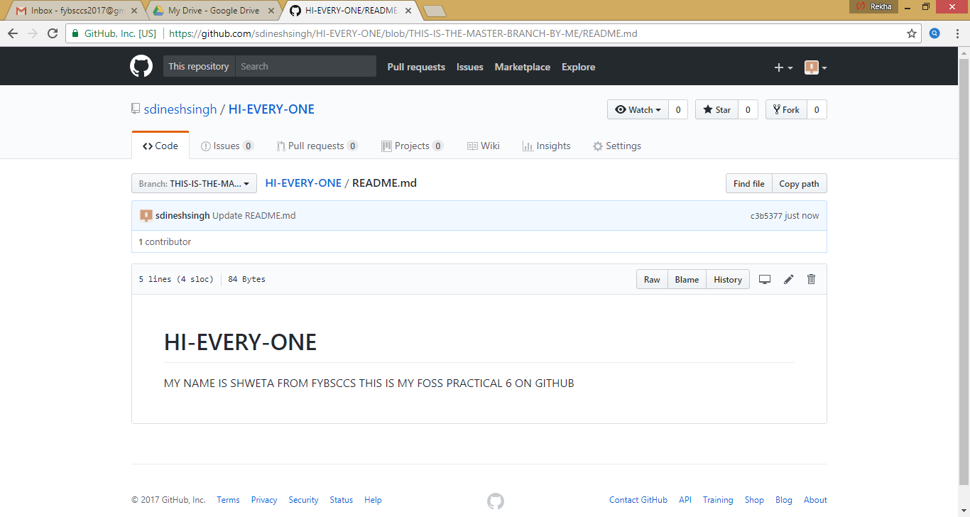

Step -4 To open a Pull Request ,
click the pull request tab

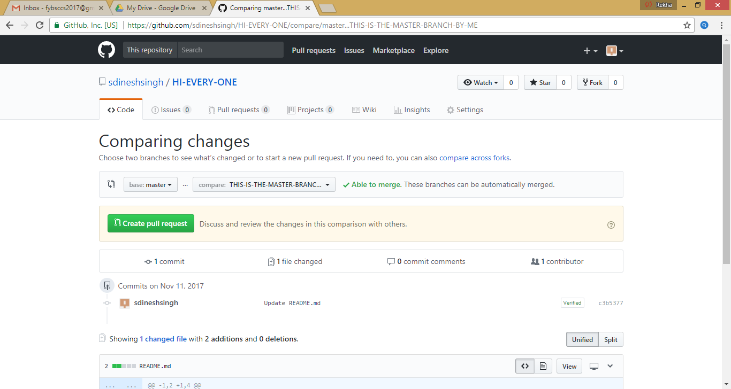

Select the branch you made ,readme-edits ,to compare with master

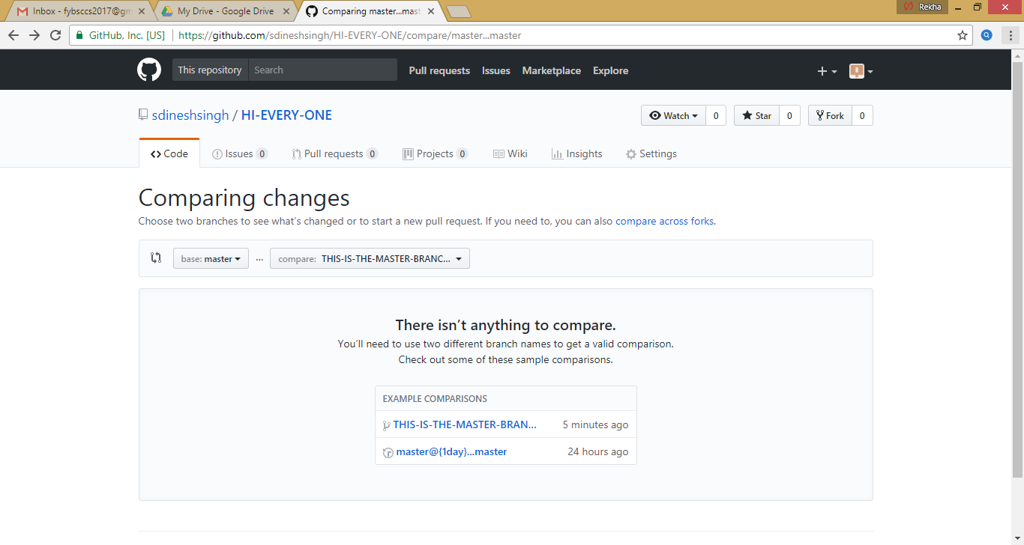

Look into the changes made

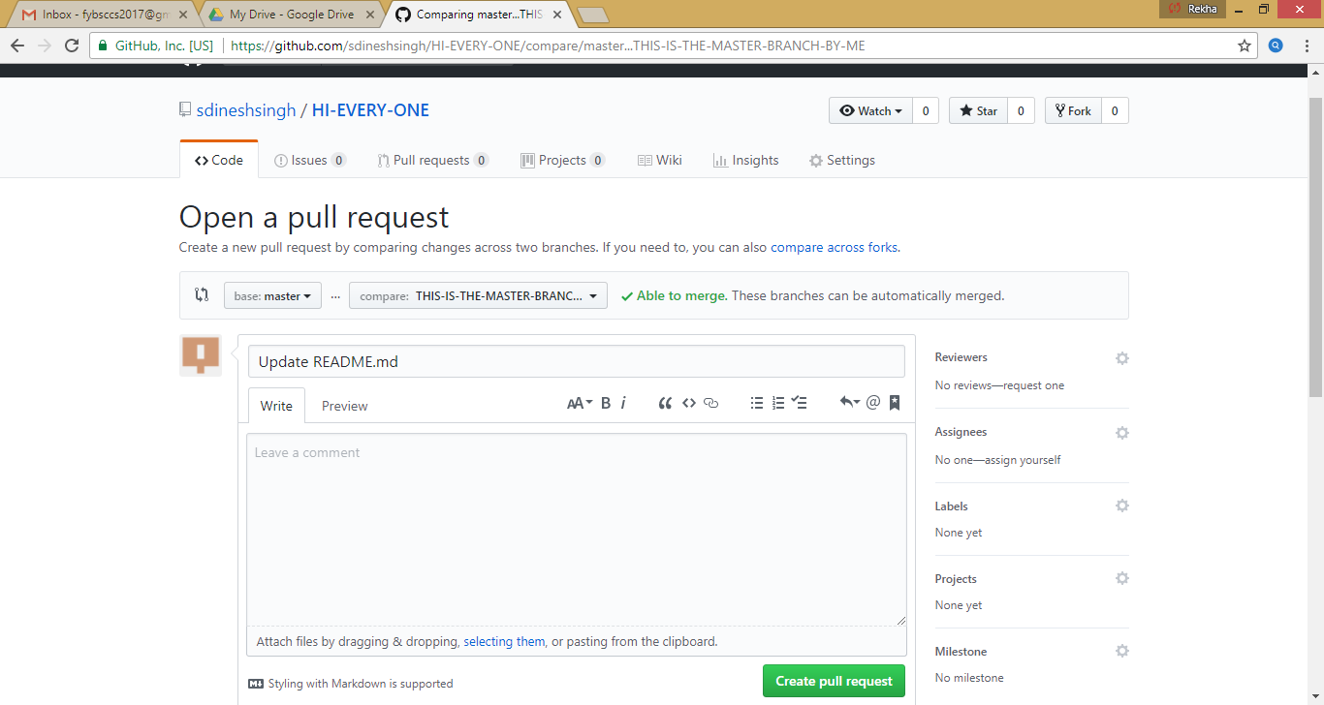

Step-5 Merge your pull request
Click on the green Merge pull request button to merge the changes into
master

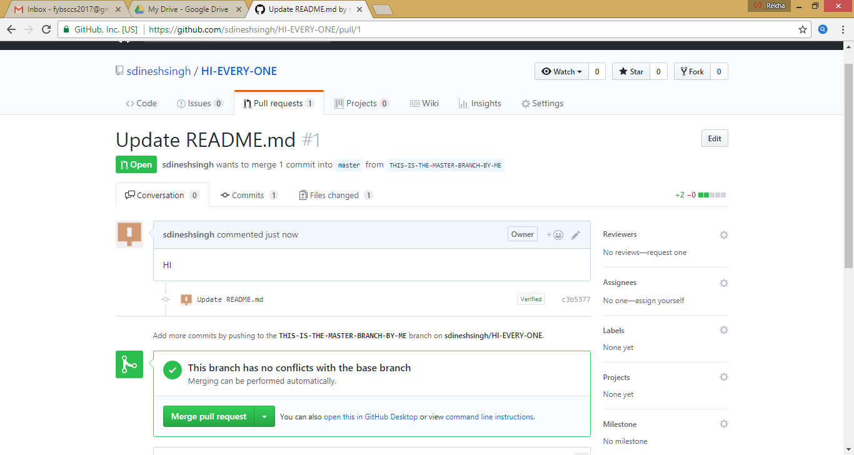

Click on confirm merge

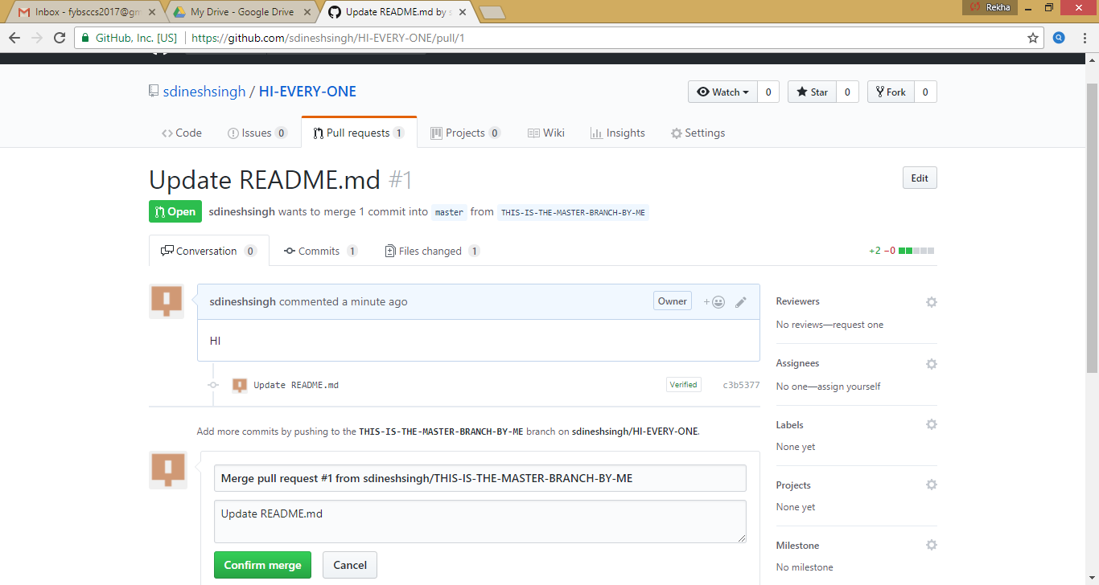

The following window appears

